**Implementing A Machine Learning (ML) Model For Image Classification**

A Project Report

submitted in partial fulfillment of the requirements

of

AICTE Internship on AI: Transformative Learning

with

TechSaksham – A joint CSR initiative of Microsoft & SAP

by

**Yogita Rajendra Pansare , siddhipansare934@gmail.com**

Under the Guidance of

**Abdul Aziz Md**

**Master Trainer, Edunet Foundation**

**ACKNOWLEDGEMENT**

We would like to sincerely thank everyone who supported and guided us during this project.

First and foremost, we express our deepest gratitude to our supervisor, **Abdul Aziz Md** for their invaluable mentorship and constant encouragement. Their guidance and constructive feedback have been instrumental in shaping this project. The confidence they placed in us motivated us to give our best and successfully complete this work.

It has been a wonderful experience working under their supervision. Their advice and insights not only helped us with the project but also enriched our learning and personal growth, making us more skilled and responsible professionals.

**Your’s Sincerely,**

**Yogita Pansare**

#### **ABSTRACT**

This project focuses on implementing a machine learning (ML) model for image classification. Image classification is a process where a computer learns to identify and categorize images based on their content.

**ProblemStatement:-**   
With the growing amount of visual data, there is a need for accurate and efficient systems to automatically classify images. Traditional methods are often time-consuming and lack precision, especially with large datasets.

**Objectives:-**  
The main goal of this project is to design and implement an ML model capable of accurately classifying images into predefined categories. This involves selecting a suitable algorithm, training the model on a dataset, and evaluating its performance.

**Methodology:-**  
The project uses a supervised learning approach, employing a Convolutional Neural Network (CNN) for its effectiveness in image-related tasks. The model is trained on a labeled dataset, and techniques such as data augmentation are applied to improve its accuracy. Python, TensorFlow, and Keras are the primary tools used for development.

**KeyResults:-**  
The implemented model achieved satisfactory accuracy in classifying images. The performance was measured using metrics like precision, recall, and overall accuracy. The results demonstrated the effectiveness of the chosen methodology.

**Conclusion:-**  
This project successfully implemented an ML model for image classification, showcasing its potential in automating tasks involving visual data. The work highlights the importance of ML in handling large-scale data efficiently. Future enhancements could include using advanced architectures and larger datasets for better performance.

|  |
| --- |
| **TABLE OF CONTENTS**  Abstract  **Chapter 1. Introduction**  1.1 Problem Statement  1.2 Motivation  1.3 Objectives  1.4. Scope of the Project  **Chapter 2. Literature Survey**  **Chapter 3. Proposed Methodology**  **Chapter 4. Implementation and Results**  **Chapter 5. Discussion and Conclusion**  **References** |

**LIST OF FIGURES**

|  |  |  |
| --- | --- | --- |
|  |  | **Page No.** |
|  | 4.1.1 Input image | **4** |
|  | 4.1.2 Importing image for classification | **4** |
|  | 4.1.3 Final result output | **5** |
|  |  |  |
|  |  |  |
|  |  |  |
|  |  |  |
|  |  |  |
|  |  |  |

**LIST OF TABLES**

|  |  |  |
| --- | --- | --- |
|  |  | **Page No.** |
|  |  |  |
|  |  |  |
|  |  |  |
|  |  |  |
|  |  |  |
|  |  |  |
|  |  |  |
|  |  |  |
|  |  |  |

**CHAPTER 1**

**Introduction**

* 1. **Problem Statement:** The project addresses the challenge of automatically classifying images into categories, which is crucial for efficiently handling and organizing large amounts of visual data. Traditional methods are time-consuming and often inaccurate, necessitating the use of advanced machine learning techniques.
  2. **Motivation:** This project was chosen to address the growing need for efficient and accurate image classification systems in an era of increasing visual data. Machine learning offers powerful solutions for automating this process, making it applicable across industries like healthcare, security, retail, and more. The impact includes saving time, reducing human effort, and enabling better decision-making through data-driven insights.
  3. **Objective:** The objective of this project is to design and implement a machine learning model that can classify images into predefined categories with high accuracy. This involves selecting suitable algorithms, training the model, and evaluating its performance effectively.
  4. **Scope of the Project:** This project focuses on building an ML model for image classification, specifically using Convolutional Neural Networks (CNNs). The scope includes data preprocessing, model training, and performance evaluation. While the model can handle standard datasets effectively, its limitations include potential performance drops with highly complex or unseen data and the need for substantial computational resources for large-scale tasks. Future work can address these challenges by incorporating advanced models and larger datasets.

**CHAPTER 2**

**Literature Survey**

* 1. **Review relevant literature or previous work in this domain:-**

Image classification using machine learning has been a well-explored domain. Earlier approaches relied on manual feature extraction methods like SIFT and HOG. The advent of deep learning, particularly Convolutional Neural Networks (CNNs), revolutionized this field by automating feature extraction and achieving higher accuracy. Studies have shown models like AlexNet, VGGNet, and ResNet to be highly effective for large-scale image classification tasks.

* 1. **Existing models, techniques:-**

• **AlexNet (2012):** Introduced deep learning for image classification, demonstrating significant performance improvements.

• **VGGNet (2014):** Focused on deep architectures with smaller filters to enhance accuracy.

• **ResNet (2015):** Addressed the vanishing gradient problem with skip connections, enabling the training of very deep networks.

• **Transfer Learning:** A widely used technique where pre-trained models are fine-tuned for specific tasks, reducing training time and improving accuracy on smaller datasets.

* 1. **Highlight the gaps or limitations in existing solutions :-**

• Existing models often require large datasets and extensive computational resources, making them less accessible for smaller-scale projects.

• Some models struggle with overfitting, especially on small or imbalanced datasets.

• Limited adaptability to domain-specific requirements without significant retraining.

**How This Project Addresses These Gaps:-**This project focuses on building a CNN model optimized for the available dataset and computational resources, ensuring a balance between accuracy and efficiency. Techniques like data augmentation and fine-tuning will mitigate overfitting.

**CHAPTER 3**

**Proposed Methodology**

* 1. **System Design:-**

The system uses a Convolutional Neural Network (CNN) for image classification. It involves data collection, preprocessing, model design (CNN), training, evaluation, and testing to classify images accurately.

* 1. **Requirement Specification**
     1. **Hardware Requirements:**

• Processor: Multi-core CPU (Intel i5/i7 or equivalent)

• RAM: 8GB minimum

• GPU: Dedicated NVIDIA GTX/RTX for faster training

• Storage: 50GB free space

* + 1. **Software Requirements:**

• OS: Windows, macOS, or Linux

• Programming Language: Python

• Libraries: TensorFlow/Keras, NumPy, Matplotlib, seaborn,sklearn

**CHAPTER 4**

**Implementation and Result**

* 1. **Snap Shots of Result:-**

**4.1.1 Input image**

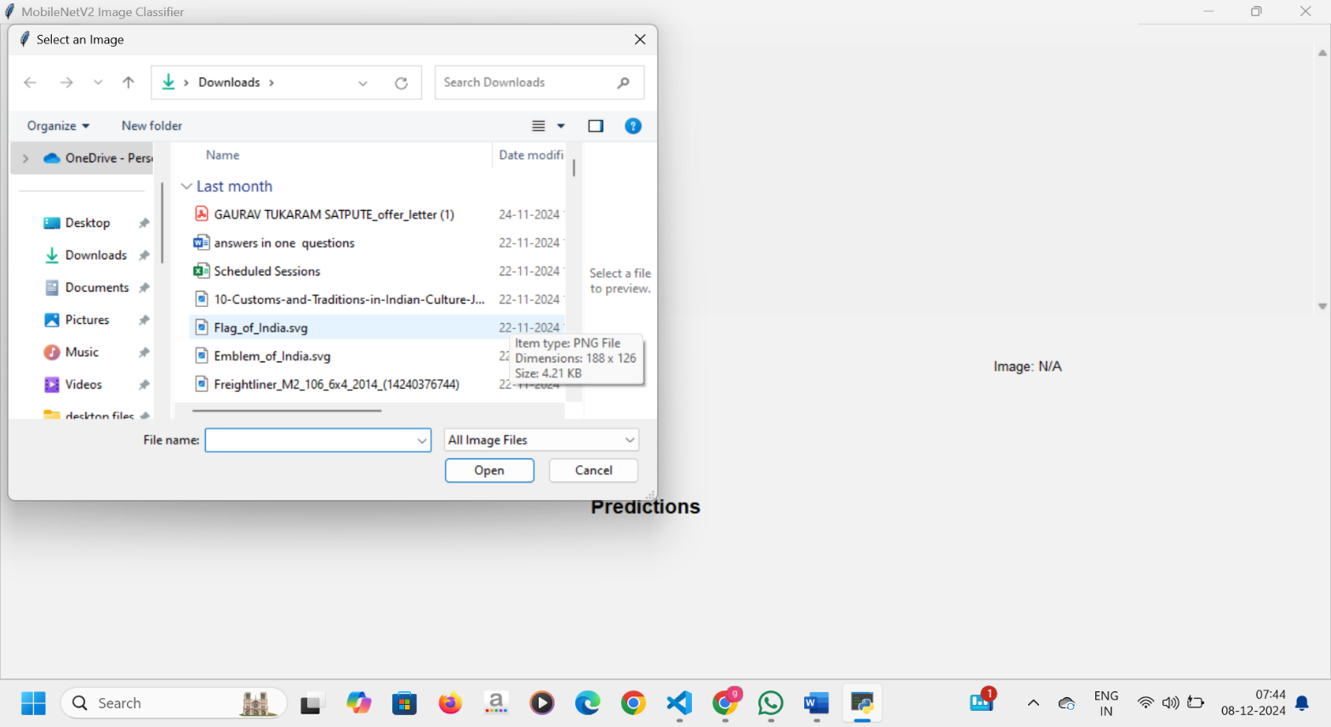**4.1.2 Importing image for classification**

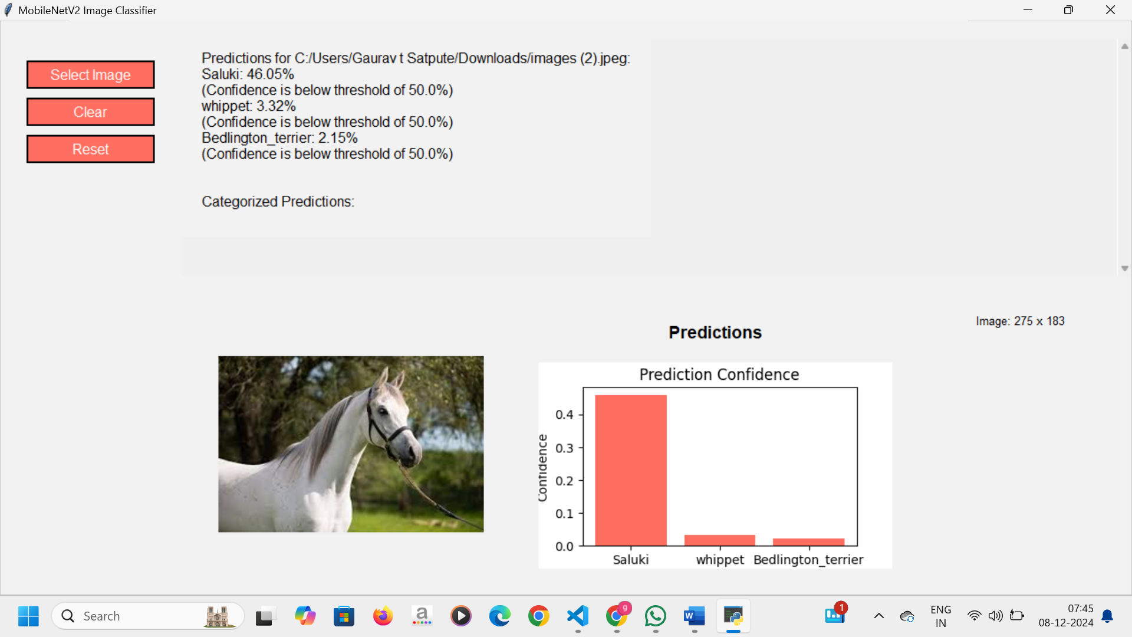

**4.1.3 Final result output**

**4.2 GitHub link for code**:

[**https://github.com/Yogitapansare/image-classification.git**](https://github.com/Yogitapansare/image-classification.git)

**CHAPTER 5**

**Discussion and Conclusion**

* 1. **Future Work:**

To improve the model, several strategies can be explored:

* **Advanced Models:-** Implement more advanced architectures like ResNet or EfficientNet for better performance, especially with larger and more complex datasets.
* **Transfer Learning:-** Use pre-trained models and fine-tune them to save time and improve accuracy, especially with limited data.
* **Hyperparameter Tuning:-** Experiment with hyperparameter optimization (e.g., learning rate, batch size) to improve model efficiency and accuracy.
* **Larger Datasets:-** Train the model on larger, more diverse datasets to enhance its generalization ability and reduce overfitting.
* **Real-time Classification:-** Implement real-time image classification for dynamic environments, like video streams or live image feeds.

**5.2 Conclusion:** This project successfully implemented a machine learning model for image classification, demonstrating the power of Convolutional Neural Networks (CNNs) in automating the categorization of images. The model achieved promising results, providing a solid foundation for real-world applications in fields like healthcare, security, and retail. The project's contribution lies in its ability to process large volumes of visual data efficiently and accurately, offering a scalable solution for various industries. Future enhancements can further optimize the model and broaden its applicability.

**REFERENCES**

1. **Keras Documentation**: A beginner-friendly guide to building models with Keras.
   * Keras Documentation
2. **TensorFlow Image Classification Tutorial**: A step-by-step tutorial for image classification using TensorFlow.
   * TensorFlow Tutorial
3. **Fast.ai Course**: A practical course on deep learning that includes image classification.
   * Fast.ai Course
4. **PyTorch Image Classification Tutorial**: A simple guide to image classification using PyTorch.
   * PyTorch Tutorial
5. **Google Colab Notebooks**: Pre-built notebooks for image classification tasks.
   * Google Colab